DHCC Health Information Protection Regulation Compliance for Log360
Tagline: Support DHCC health information security compliance with Log360.

Overview
The DHCC Health Information Protection Regulation Compliance extension for Log360 helps Dubai Healthcare City Authority-licensed healthcare providers meet the information security, data access audit, and breach notification requirements of the DHCC Health Information Protection Regulation.
Log360 collects and analyzes logs from clinical information systems, electronic health records, cloud environments, and network infrastructure, providing security teams with continuous visibility into patient data access events. Compliance and privacy teams can detect unauthorized data access, investigate incidents, and generate DHCCA-ready audit documentation.

Key Features
- Generate predefined audit reports covering DHCC Health Information Protection Regulation requirements including patient data access monitoring and security incident detection.
- Monitor access to protected health information across DHCC-licensed clinical systems and detect unauthorized queries and bulk exports in real time.
- Configure threshold-based alerts for health data security events such as unauthorized record access, audit log tampering, and anomalous user behavior.
- Export compliance evidence in PDF and CSV formats for DHCCA regulatory reviews and internal healthcare information governance.
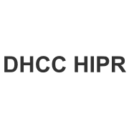
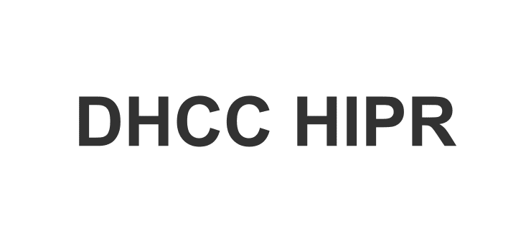

Screenshots
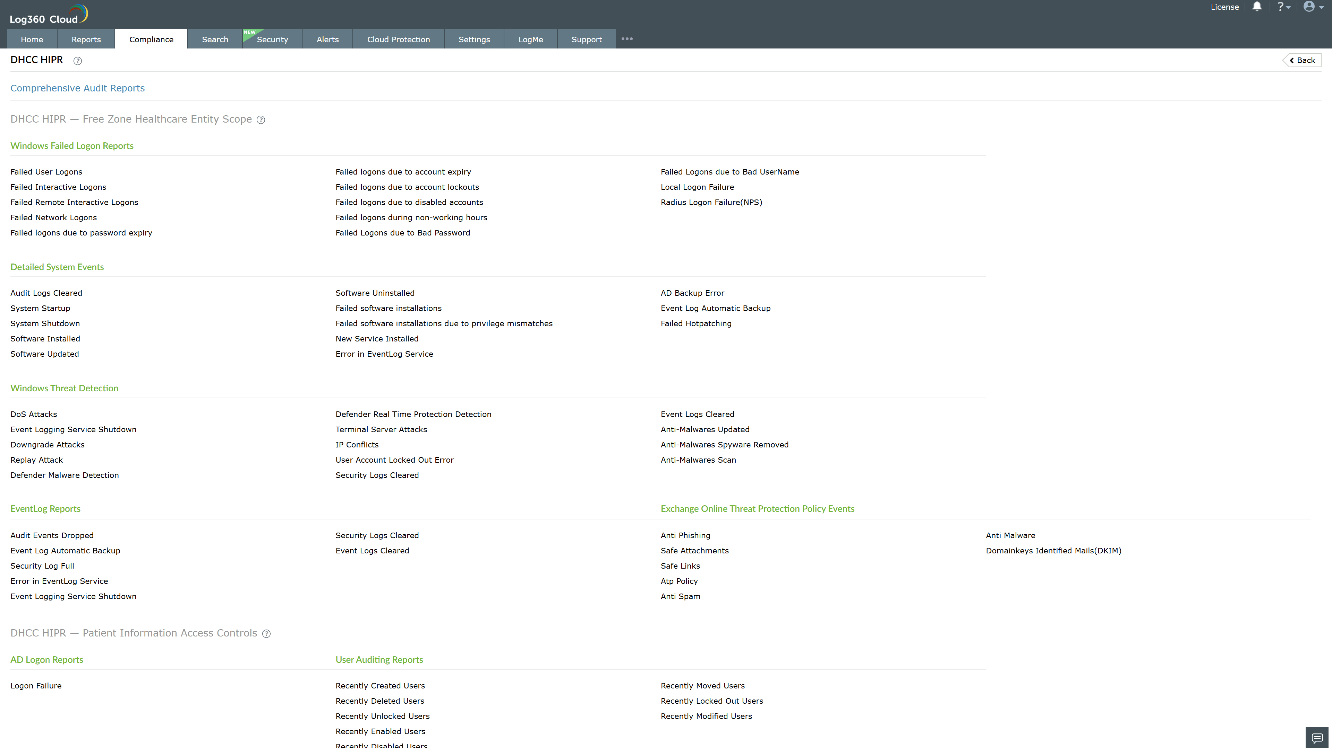
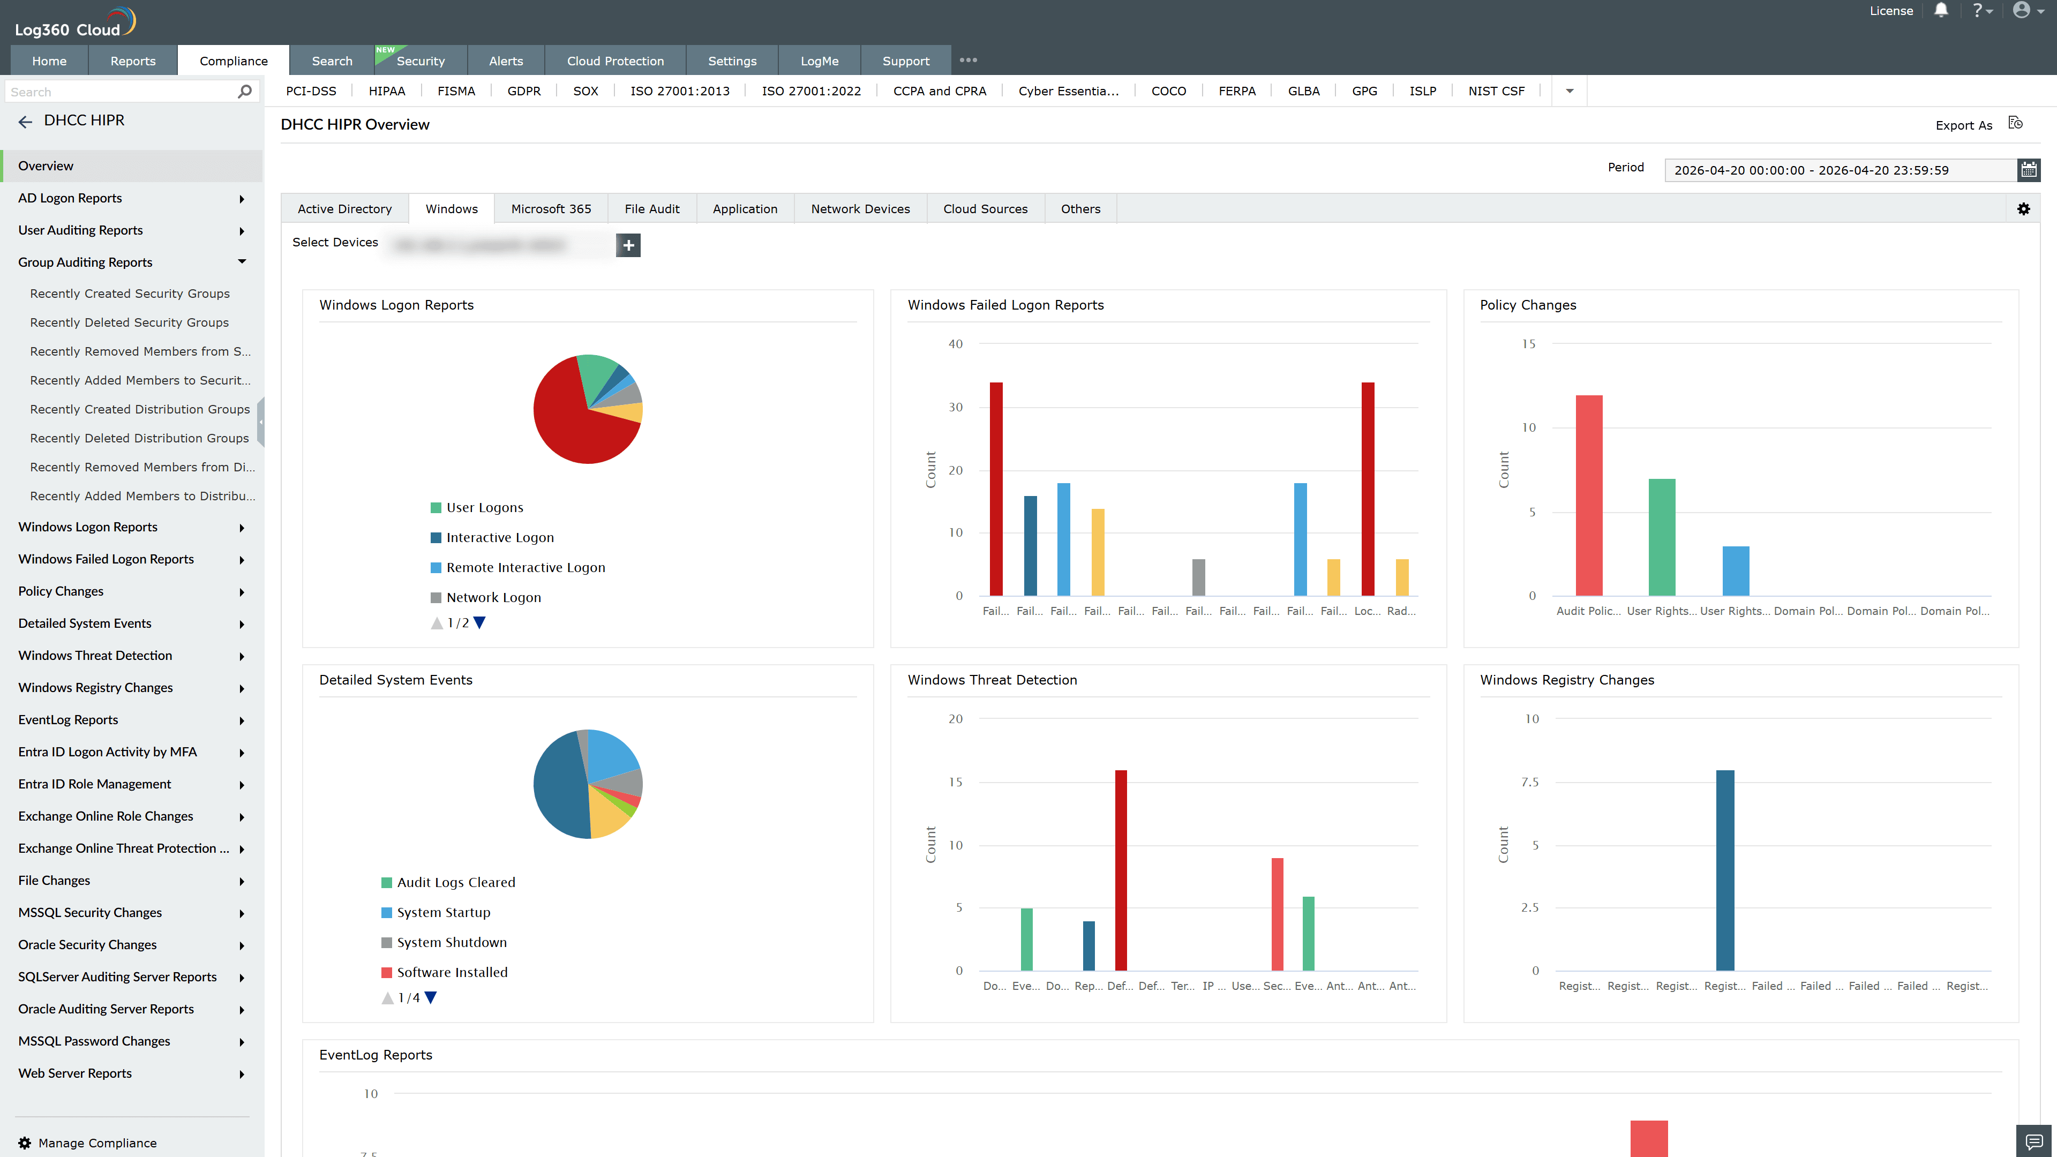
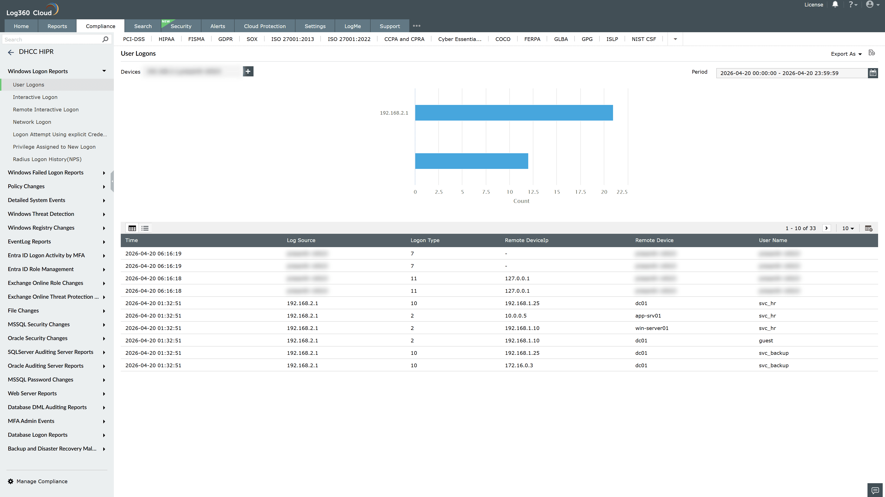
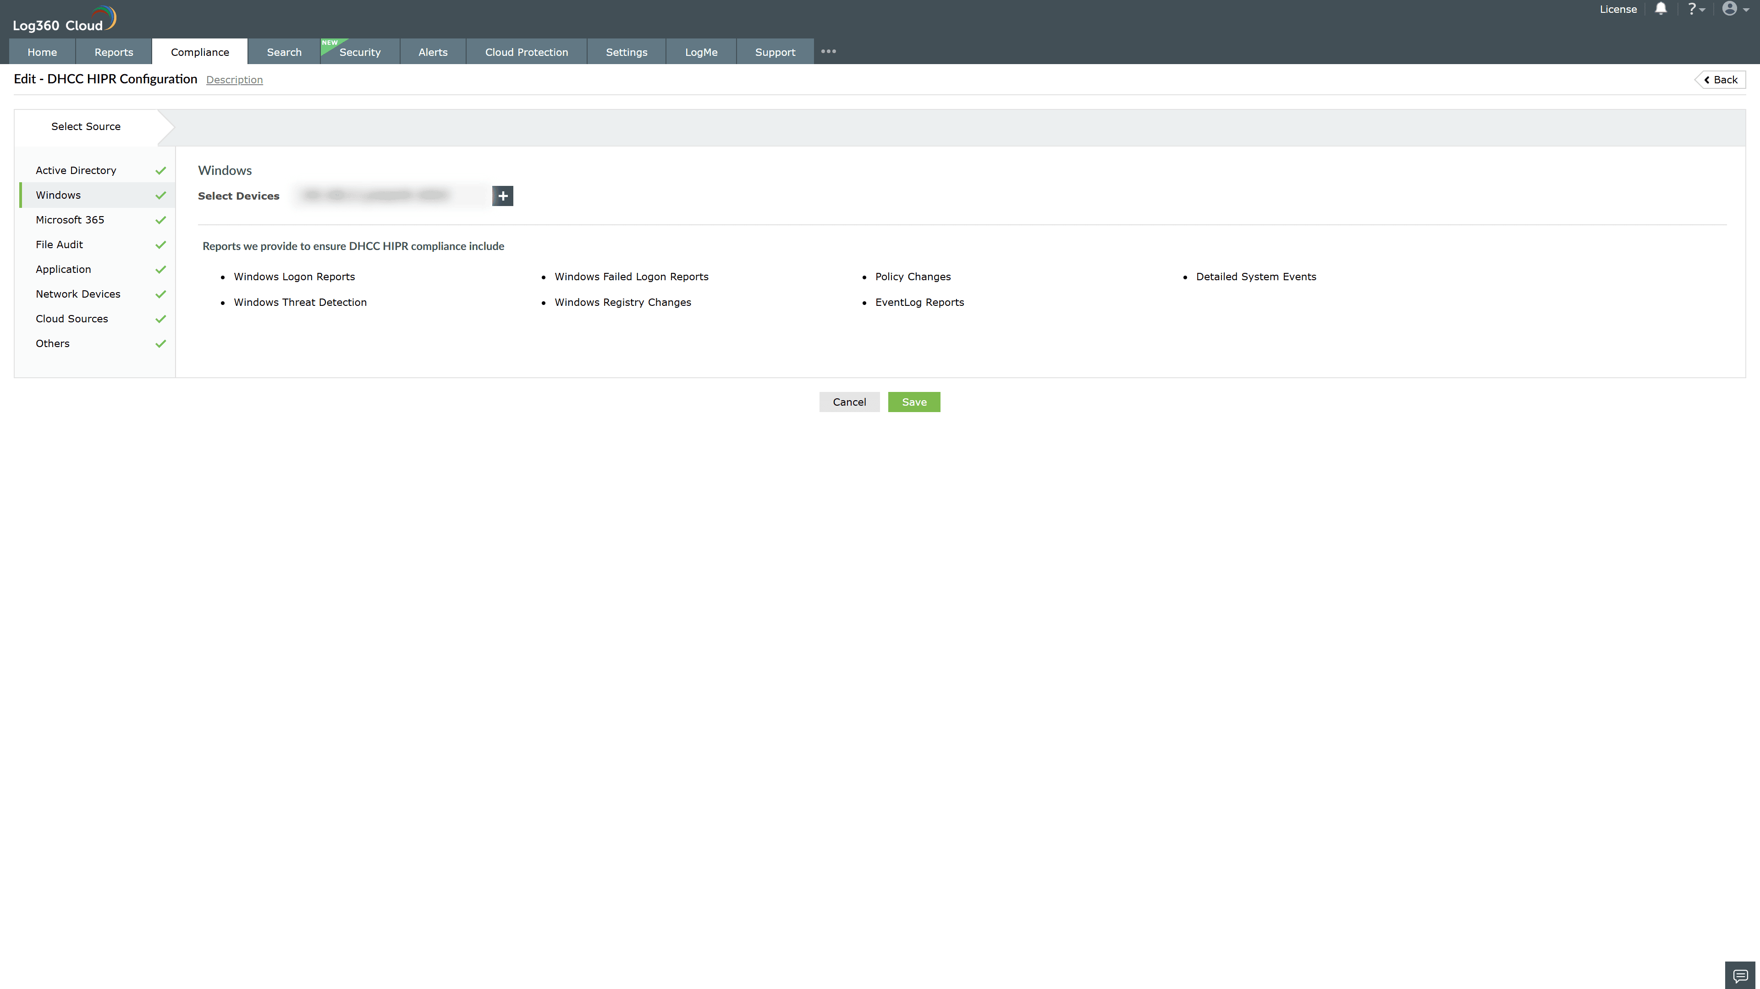

Valid Submission : Yes
Supported Editions : Free, Basic, Standard, Professional, MSSP
Help Document : https://www.manageengine.com/log-management/help/integrations/compliance-extensions.html
Help Video : Not provided
Tags : Log360, Compliance, Privacy monitoring, Data privacy, Regulatory compliance
Supported DCs : US, IN, JP, CA, AU, UK and EU
Privacy Policy:
Terms of Service:
Release Notes:
Predefined reports for the DHCC Health Information Protection Regulation Compliance

